is there any standarad table with these dicom tags?

Yes! Below is a **standardized reference table** for the key DICOM tags used in radiographic positioning, including their definitions, relationships, and correct usage for different exam types. This aligns with DICOM Standard PS3.3 (Information Object Definitions) and PS3.16 (Content Mapping Resource).

**DICOM Tags for Radiographic Positioning**

| **Tag (Group,Element)** | **Keyword** | **Description** | **Valid Values** | **Example (Clavicle LAT RT)** | **Notes** |
| --- | --- | --- | --- | --- | --- |
| **(0018,5101)** | ViewPosition | Direction of X-ray beam relative to patient (beam entry → exit). | AP, PA, LL, RL, RLO, LLO, etc. | RL (Right Lateral) | Beam enters left side, exits right side (right clavicle on detector). |
| **(0018,5100)** | PatientPosition | Patient's physical orientation on the table (e.g., supine, prone). | HFS (Head First Supine), FFP (Feet First Prone), etc. | HFS (if supine) | Not to be confused with ViewPosition. |
| **(0018,9401)** | ViewCodeSequence | Structured description of the projection (e.g., "Lateral", "Oblique"). | SNOMED CT or DICOM-defined codes. | 399162004 (Lateral view) | Preferred for detailed documentation. |
| **(0020,0060)** | Laterality | Side of paired body part (if applicable). | R, L, B (both), or omitted. | *Omit* (clavicle is unilateral) | Only for paired structures (e.g., breasts, lungs). |
| **(0020,0062)** | ImageLaterality | Side of the body part actually imaged. | R, L, B (both). | R (Right clavicle) | Required for unilateral exams. |
| **(0018,1500)** | BodyPartExamined | General anatomic region (free-text). | CLAVICLE, CHEST, SKULL, etc. | CLAVICLE | Vendor-specific values may vary. |
| **(0008,2218)** | AnatomicRegionSequence | Detailed anatomic location (structured). | SNOMED CT codes. | 85756007 (Clavicle bone) | More precise than BodyPartExamined. |
| **(0018,5102)** | Orientation | **Primary anatomical plane** of the projection (coronal, sagittal, oblique). | AP, PA, LATERAL, OBLIQUE. | LATERAL (or OBLIQUE) | Often misused—should reflect anatomy, not beam. |

**How to Use This Table**

1. **For a Clavicle LAT RT**:
   * ViewPosition = RL (beam left→right, right side on detector).
   * Orientation = LATERAL (sagittal plane alignment).
   * ImageLaterality = R (right clavicle).
   * Laterality = *Omit* (not a paired structure).
2. **For a Chest PA**:
   * ViewPosition = PA (beam posterior→anterior).
   * Orientation = PA (coronal plane).
   * Laterality = *Omit* (unless lung-specific).
3. **For a Knee AP Left**:
   * ViewPosition = AP (beam anterior→posterior).
   * Orientation = AP (coronal plane).
   * ImageLaterality = L.

**Standards Reference**

* **DICOM PS3.3**: Defines these tags in the "DX Positioning" module (e.g., DX Anatomy Imaged, DX View Position).
* **IHE RAD-TF**: Recommends consistent use of ViewCodeSequence for interoperability.
* **SNOMED CT**: Provides standard codes for AnatomicRegionSequence and ViewCodeSequence.

**Common Pitfalls**

* **Mixing**ViewPosition**and**Orientation:
  + AP/PA in Orientation = coronal plane.
  + AP/PA in ViewPosition = beam direction.
* **Overusing**Laterality: Only for truly paired structures (e.g., not spine or skull).

Would you like a mapping for a specific exam type (e.g., scoliosis series, portable chest)?

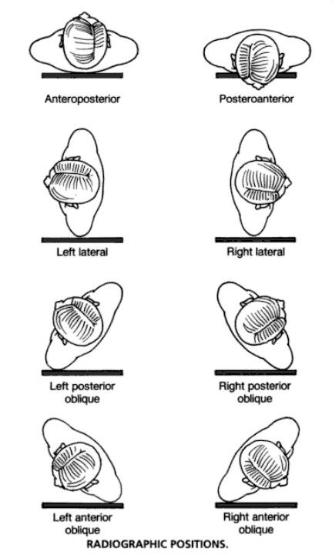

Radiographic views. The term radiographic “projection” references the path of the central ray as it exits the x-ray tube and passes through the patient’s body. For example, **A** denotes an anteroposterior (AP) projection and **B** a posteroanterior (PA) projection. In the extremities, lateral projections are similarly described by the direction of the central ray; hence, mediolateral and lateromedial projections are possible. However, when one deals with the head, neck, or body tunk, the lateral and oblique projections are further clarified by the specific “position” of the patient. Position denotes the placement of the patient’s body, specifically the portion of the patient’s anatomy that is in contact with the Bucky. For example, **C** indicates a lateral projection in a right lateral position and **D** indicates a lateral projection in a left lateral position. In **E,** the patient is in a left anterior oblique (LAO) position, and in **F** the patients is in a right anterior oblique (RAO) position, both corresponding to posteroanterior oblique projections.